Lab 6: Spark with Python

Name:

1. Execute the following commands in spark interactive shell and paste the output screenshots:

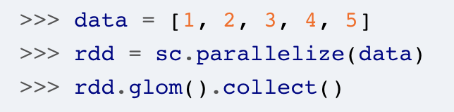

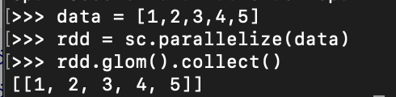

2. Execute the following commands in spark interactive shell and paste the output screenshots:

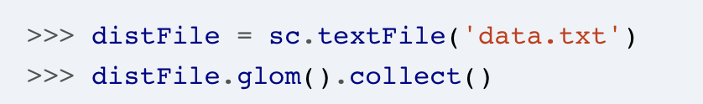



3. Execute the example to calculate the number of characters in a file and paste the output screenshots:

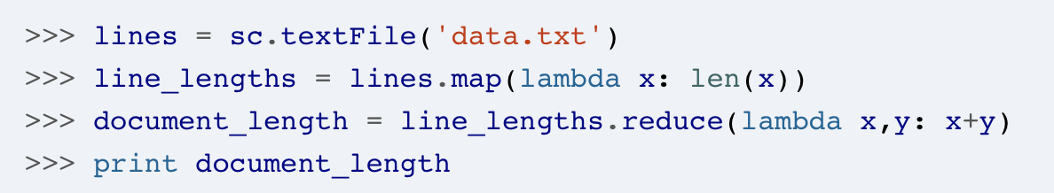

4. Execute the “word count” example and paste the output screenshots:

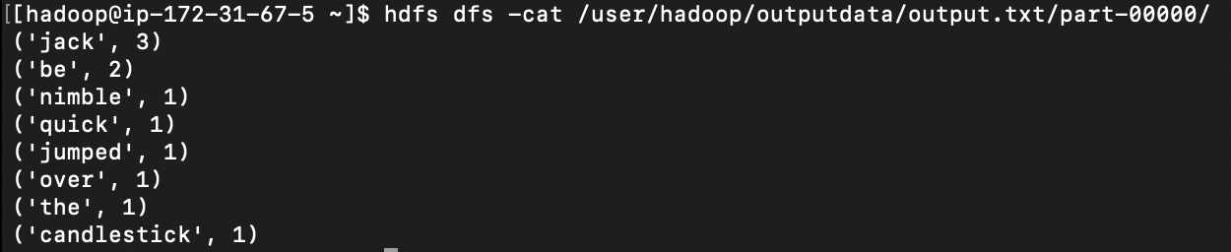

5. Execute the “text search” example and paste the output screenshots:

